Website Introduction:

*Research, Analyze and Provide Historical Rationale for a Design from the Collection of the Chicago Design Archive*

In this art history lesson plan, students are asked to break down one design work in the CDA collection into its key visual elements through close looking and study. Students are then asked to trace these key elements to a source further back in history by way of looking at other examples of design from earlier decades, doing research on historical sites (newspapers, journals, advertising, publicity, digital archives and libraries, etc.). Students write an interpretation of the work they choses from the CDA collection based on a synthesis of their close visual analysis and historical tracing to sources or rationales for a given design.

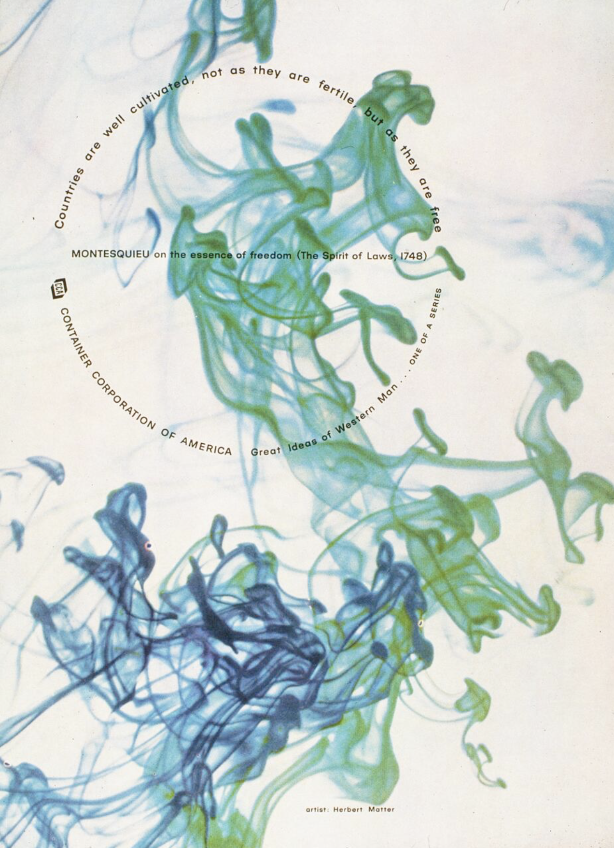

_______________________________________________________________________

**Project Title:**

*Research, Analyze and Provide Historical Rationale for a Design from the Collection of the Chicago Design Archive*

**Project Overview:**

Select a work form the Chicago Design Archive website. It can be from any decade and in any medium. Analyze it by tracing each of its design elements to a source in order to provide a historical analysis and rationale for each design aspect. Start with a visual description of the design, that includes a detailed study of its features/elements.

**Project Aims and Learning Outcomes:**

The goal of this assignment is to familiarize students with the CDA as a site for historical design research.

The students will also develop their skills in close, attentive looking and textual (written) description of the visual. The assignment requires students to absorb the overall visual effect of the design that they choose as well as the details and elements that contribute to the total effect. It requires students to move back and forth between the total design and its parts; between the visual and the historical.

The students will develop their research skills. They will need to start with something that is in front of them (on their screen) and trace the design elements and features back to a source to provide a historical rationale for each element.

The students will use historical research and reasoning to provide a rationale or detailed interpretation of one of the design works in the CDA digital collection.

**Research Sources and other required materials**:

[chicagodesignarchive.org](http://chicagodesignarchive.org) (images and supporting documents and texts)

Course lecture notes and reading notes

Research on museum and cultural institution websites (for example: Victoria and Albert Museum; Museum of Modern Art; Smithsonian, etc.)

Research on Flaxman Library databases: newspapers, articles, journals.

**Details of Activities in Preparation for Assignment:**

Provide students with background on CDA collection. Spend some time reviewing the organization of the website and some of the design work within. Show programming achievements, oral and written histories, and other features of the website that provide a comprehensive overview of Chicago design through the decades.

Provide an example for students by selecting one of the works and demonstrating the process of deep visual analysis and historical research.

**Assignments/work steps**:

On your computer or pad, go to chicagodesgnarchive.org.

Near the top of the page, open “Dates” tab. This displays the digital collections organized by decade and year produced. This is one way to explore the collection, but you can consider other ways to “enter” the collection: for example, by “designer” or “client,” if you have something more specific in mind.

Spend 15-20 minutes exploring. Note any works in the collection that you find visually interesting. Select a work that you will use as the basis for the assignment.

Once you select your design work, spend 10 minutes closely analyzing it. Write down things you notice about the visual aspects of the design.

Write a visual description of your work. This should include a description of its total effect/impact and of its details. The description should also include any information that can be found on the website. Who was the designer? What year was the design created? In what context did it circulate/exist? What was its function? Who was the client/manufacturer?

Research phase. Trace each of the elements of your chosen design work to a source in order to create a rationale for its use. This will serve as an exploration of the designer’s intentions within the framework of history. It will also serve as a kind of interpretation based on a philological approach—a tracing backwards to search for sources.

**EXAMPLE:**

2B1- Great Ideas Ad 105 by Designer Herbert Matter. Advertisement for Container Corporation of America, 1958. “Great Ideas of Western Man” series.

There are several things I notice about this graphic at first glance. First it is highly unstructured. Nothing is really being sold, except perhaps a certain idea of freedom as expressed in the mid-18th century by Montesquieu. The imagery is not specific. It is abstract photography playing with motion and color. The imagery is etherial; it floats, loops, and moves off the page in all directions. Inserted over the flowing, billowing, formless, movements of the background design is a quotation and identifier organized in a structured circle with a line in the center. The text does not sell a product or a service but expresses an idea: “Countries are well cultivated, not as they are fertile but as they are free.” The middle line acknowledges the source of the quote, Montesqueu’s’ *The Spirit of Laws* published in 1748. The lower portion of the text identifies the sponsoring corporation of the advertisement, Container Corporation of America with a logo and name spelled out, and the title of the advertising series, “Great Ideas of Western Man.”

At the very bottom of the page is an acknowledgment of the designer, who is referenced as an artist, Herbert Matter.”

There are several points in which to enter the image and to take elements back in time to a source or a rationale. These can take the form of questions: Who was Herbert Matter? What other works did he do? Was he an artist? Designer? Where did he work? Who was Montesquieu? Why was his idea relevant to CCA, or a corporate advertisement from 1958? What could the meaning of the quotation be in 1748? In 1958? Where does the imagery come from, or the method of producing color motion photography? Why was it deemed as an appropriate representation of this idea? For this corporation? Who was Container Corporation? What did they produce? Why did they want to publish ideas from the Western tradition in their advertising campaign? Did other corporations do similar campaigns at the time?

Begin the research process based on these set of questions or strands of historical connections uncovered by the visual analysis. I find a copy of Bacon de Montesquieu’s book *The Spirit of Laws*on archive.org. The book is about forms of government and how laws function under divergent models, democracies or republics, monarchies, and despotic states. He speaks of virtues such as the “love of equality” as emerging out of political conditions, not religious or moral ones. As such, such political virtues such as this one are connected to republican (or democratic) forms of government, in which humans embrace the laws of their countries. Laws are the glue that hold a community together and express the political virtues of a given form of government. Montesquiu wrote his treatise in the age of Enlightenment, which can be described roughly as a period during which a developing consciousness of human’s own role in historical processes arose. In the 18th century, the new fields of calculus and mechanics began to influence thinking around the working of the universe. John Locke, Thomas Hobbes and others would develop a notion of democracy that would ultimately supplant the monarchical power structure of the European continent. Adam Smith, in the late 18th century, put forward economic ideas that would provide the intellectual basis for the development of modern capitalism. It was also a period that science became a central piece of public discourse.

Herbert Matter was a Swiss-born American photographer and graphic designer who is known for his use of photomontage in commercial art. He used “light drawing” in the advertising in the CDA website, and was also a film maker. Stanford library has a collection database of some of Matter’s photographic images. HIs work is abstract, experimental. For example, he did some commercial work for Knoll and he presents one of Harry Bertoia’s chairs from above, in which it does not appear as a chair, but as an abstract grid. He documents the sculptural and two dimensional work of the artist Alberto Giacometti and presents floating driftwood against a black ground in some of his work. What does Giacometti’s sculptural work and this type of abstract photography have in common? Both are non-linear, present the the scattered, and present the condition of blurring space.

|  |  |  |  |
| --- | --- | --- | --- |
| **Depth of visual analysis.** | Close reading and analysis of all elements of designs. | Somewhat close reading, although certain elements are not addressed. | Minimal consideration of the visual elements of the selected designs. |
| **Analysis of key elements in design to trace historically.** | In-depth consideration of the project and its key features to trace back through historical consideration | Some consideration of the project’s key features as they relate to historical precedents. | Minimal to no exploration of the important visual elements of the selected work. |
| **Research-based Contextualization.** | Brought in research sources that shed important insights onto the works. | Brought in sources that were interesting and shed some light on the works’ context. | Brought in sources that were not relevant to the works or did not do any research. |
| **Inductive Reasoning.** | Strong induction based on deep visual and researched analysis. | Induction is logical, although only moderately tied to your analysis. | No inductive reasoning based on visual analysis and research. |
| **Development of an interpretive narrative.** | Construction of a historical narrative based on in-depth researched study | Construction of a narrative of design history that demonstrates some level of research depth. | No narrative or sense of historical consideration of the work and its elements based on research. |

The imagery of the advertisement expressed the abstract, experimental approach to photography that was brought to the United States by members of the avant-garde working in Europe in the 1920s, including Matter, Laszlo Moholy-Nagy (who came to Chicago), and some of the photographers who taught in Chicago at the School of Design (where Moholy was director between 1937 and 1946). Cameraless photography, color photography, a focus on visual features such as texture and the exploration of light as a medium of drawing or painting all were taught by photography instructors at the school.

The ties between the imagery and the text in the advertisement are fundamental to the interpretation of any advertisement. The text (copy) and imagery were always conceived to support each other, to mirror one another, or to establish some kind of bond where the sales pitch or information was reinforced. If we apply this traditional reading of print advertising, it is possible to consider the expression of movement as an articulation of “freedom”. The abstraction and freedom to express in one’s own medium in the context of the highly structured commercial world of advertising graphics, also communicates the ideal of artistic freedom, that was essential to mid-20th century rhetoric and the celebration of the Abstract Expressionists by American media and governmental communications during the Cold War.

Other elements of the graphic to historically track and trace:

Why a focus on Enlightenment ideas in a commercial advertisement in mid-20th century America? Why a reflection on ideas such as the concept of freedom during this time?

What typeface is used? Why?

Where does the idea of acknowledgment of the graphic designer as artist in an advertising page come from?

Where does the layout of copy in a non-linear manner begin? What are its possible sources?

**Instructor Reflection and Student samples (optional):**

*What went well? What would I do differently next time? Next steps? Things to remember?*

