Course name, Instructor name, and date:

Survey of Design History, ART HISTORY 1015
School of the Art Institute of Chicago
Lara Allison, Department of Art History, Theory and Criticism
Fall 2024

Project Title:

Compare Design Work from Two Decades

[Note that this can be done as an individual assignment or partner-based/collaborative]

Project Overview:

Select two works from the Chicago Design Archive website. The works can be from any decade (1860s to 2020s), but they must be from separate decades. Using descriptive language and historical knowledge drawn from lectures and readings as well as supplemental research, write a one to two page summary comparing the two works. The paper should be double spaced, 12 point type. Include copies of the images on a separate page. The images should include captions: name of designer, date of project, title, etc.

Project Aims and Learning Outcomes:

The goal of this project is to familiarize students with the CDA as a site for historical design research. By searching through the database by decade, students will be able to see the way that design expression changes through time.

The students will develop their skills in visual analysis and verbal description. What visual features are distinctive to a specific work? Are such features found on other works from that decade? How do such features appear and transform, if at all, in a later decade?

The students will use inductive reasoning to develop knowledge about design during a historical period from a close study of design elements, style, forms, typefaces used in their chosen works. They will further be able to produce conclusions about the way that design changes from one decade to another by analyzing the visual features of their two works.

The students will demonstrate their ability to write a historical design narrative using descriptive language drawn from a close study of two images in the CDA collection. The close analysis of these works will be developed into a written text that draws larger conclusions about design in Chicago, change and progress in design movements and styles, and technological, economic, and social/political transformations through time.

Research Sources and other required materials:

chicagodesignarchive.org (images and supporting documents and texts)
Course lecture notes and reading notes
Research on museum and cultural institution websites (for example: Victoria and Albert Museum; Museum of Modern Art; Smithsonian, etc.)

Details of Activities in Preparation for Assignment:

Provide students with background on CDA collection. Spend some time reviewing the organization of the website and some of the design work within. Show programming achievements, oral and written histories, and other features of the website that provide a comprehensive overview of Chicago design through the decades.

Demonstrate through oral example the description and analysis of a few of the images and layout the types of inductive reasoning and narration that can be built from the visual study of the works.

Assignments/work steps:

On your computer or pad, go to chicagodesgnarchive.org.

Near the top of the page, open “Dates” tab. This displays the digital collections organized by decade and year produced.

Spend 15-20 minutes exploring. Note any works in the collection that you find visually interesting. Near the end of this explorative time allotment, select two works that will be the basis of your written comparison, analysis, reflection, and design history narrative.

Spend 10 minutes closely analyzing the work in the images you selected for your comparison. Write notes detailing the visual elements of the work.

Begin to write visual descriptions of your two works.

Do research to find other contextual clues to help you construct a narrative around your two chosen projects. Research can be done within the Chicago Design Archive website. There are texts and films and other materials that you can explore. You can also do research on other sites, or use prior knowledge you have to construct your narrative.

The works should be analyzed singly and as a pair. The narrative that you construct should be one that considers a design historical trajectory.

EXAMPLE:

1955 graphic design by Susan Jackson Keig for the Art Director’s Club of Chicago, “Aspen Issue.” On the cover of the ADCC News Bulletin from the summer of 1955, Keig reproduces the mural produced by Bauhaus designer Herbert Bayer on one of the public buildings at the Aspen Institute. Keig identifies the source in small blue print on the bottom right of the page. The mural design, which bleeds off the cover page on both sides consists of a series of undulating lines, coming close together at certain points, and spreading apart at others. In a few areas of the mural, there are open spaces where no lines exist, suggesting holes or perhaps light shadows. The lines suggest the topography of Aspen, a mountain town. The fact that there is a whole issue of ADCC News Bulletin devoted to Aspen suggests the importance of the town to mid-century designers.

She takes an existing designer’s project and uses it in a different context. What is the effect of such a strategy?

Aspen is a town of undulating geographies, but also a town known for its contributions to design discourse. By using a work that is inspired by mountain landscapes and that is associated with one of the foremost graphic designers of the 20th century, associated with the Bauhaus in its early years, she situates Aspen within a certain nexus of nature-culture.

Other factors to be considered include the connection between Chicago and Aspen. Aspen is where the Design Conferences took place; many important designers working in the middle years of the 20th century would attend these conferences and discuss design. This infers something about the emergence of design as a site for conversation. Bayer in fact worked for a Chicago-based company, Container Corporation of America, whose founder had established (with Bayer’s help) Aspen as a destination place. Keig is designing by referencing another designer…using design as a means to produce dialogues between mediums (a mural on a building in Aspen and a journal for Chicago’s Art Director’s Club.

Twenty five years after Susan Keig’s cover, Norman Perman designed a plan booklet for the town of Park Forest South. This design, like Keig’s references a place. It also does this using the abstract language of lines and shapes. It is a much bolder design than Keig’s, replacing the organic language of the natural world with references to the grids and main thoroughfares that divide place, that are constructs of the human mind, and combined with regions marked by different colors that designate residential, industrial, and natural areas. The perspective is a straight aerial view.

Park Forest is the first fully-planned, post-World War II suburb. Park Forest was a new town in the 1950s; in 1970s, Park Forest South was a new, also totally planned community. It offered a response to what was beginning to be seen by the 1970s as the disintegration of community in suburban settings as domestic outposts of the city . Park Forest South offered a new type of suburb, located just south of the city, and incorporating nature as well as industry into its plans.

Both designs offer visions of places that are outside of urban cores: one a tourist destination and the other a new type of suburb. Both employ mapping of place as the primary visual feature and minimal text. Perman’s design uses helvetica typeface which had become the commonly used face for public documents and signage by the 1980s. Keig’s design uses a softer, serifed typeface that is appropriate to the more organic lines featured on her cover. The blue color is also an homage to Herbert Bayer as it was his favorite color, often referred to as “Bayer Blue,” at Container Corporation of America, where he served as a chairman of design.

One progression in graphic design culture that I would induce from looking at these two images is that graphic design in the 1950s still referenced art, or saw itself as related to artistic disciplines such as painting and drawing, or somehow connected to it; by the 1980s, it appears, based on the work that I analyze, that graphic design has developed its own language tethered more closely to data and communications than to art.

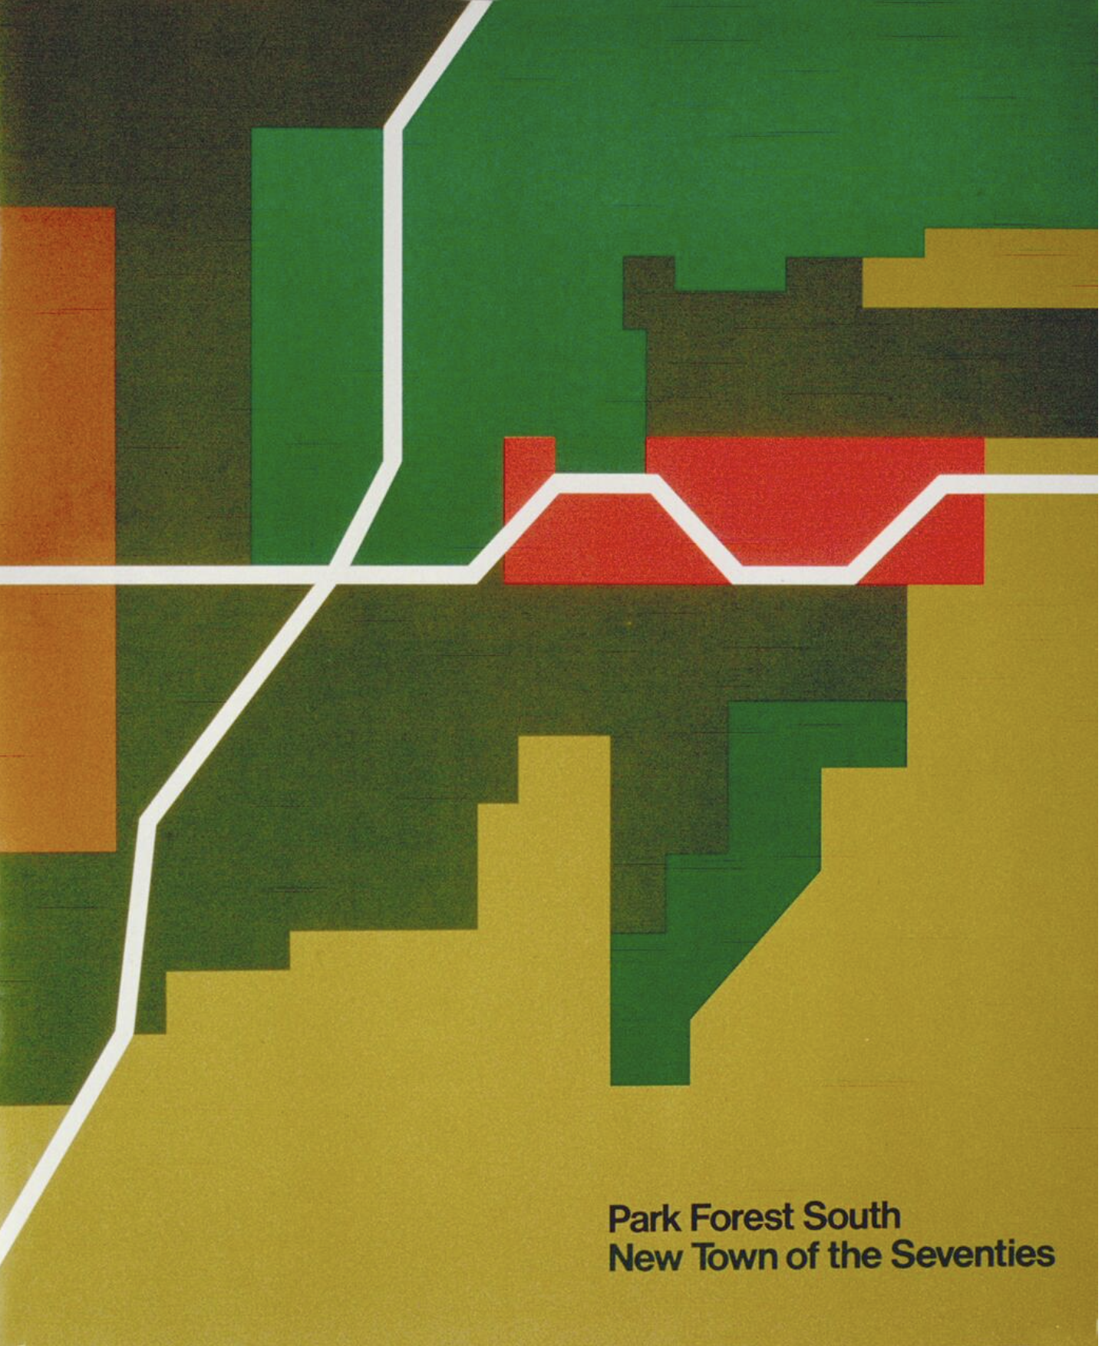

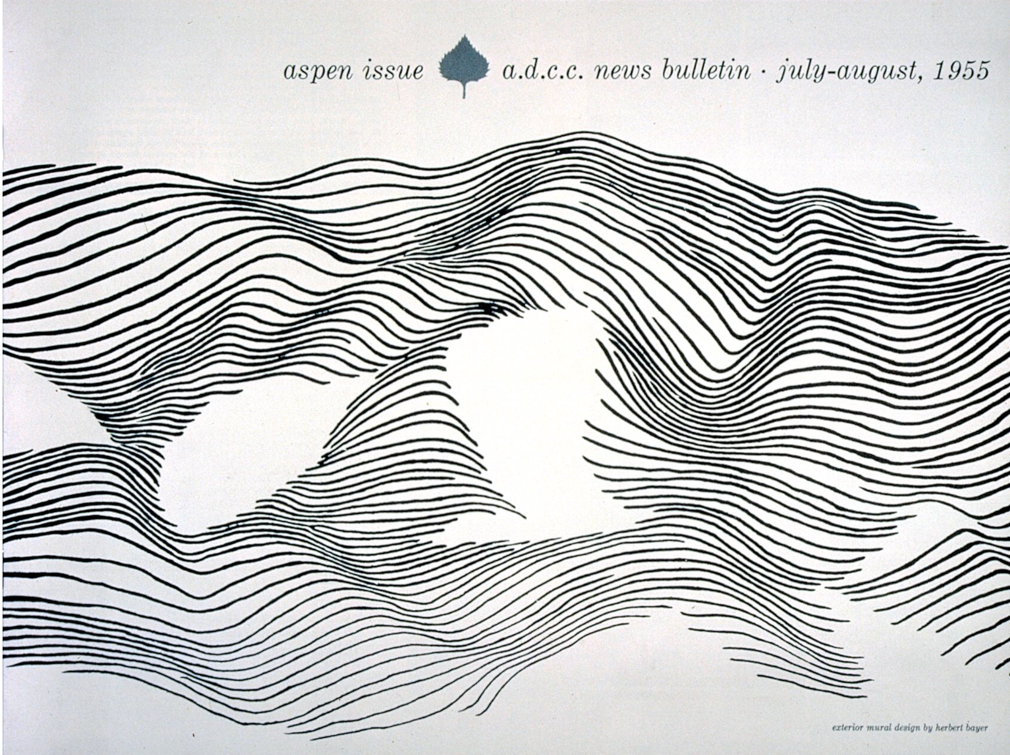

Project Rubric:

Criteria | 4-5 points | 3-4 points. | 0-2 points.
Depth of visual analysis. | Close reading and analysis of all elements of designs. | Somewhat close reading, although certain elements are not addressed. | Minimal consideration of the visual elements of the selected designs.
Comparative Analysis. | In-depth consideration of the two projects in relation to one another. | Some consideration of the two projects as they relate. | Minimal to no exploration of the reasoning behind your pairing of the two works.
Research-based Contextualization. | Brought in research sources that shed important insights onto the works. | Brought in sources that were interesting and shed some light on the works’ context. | Brought in sources that were not relevant to the works or did not do any research.
Inductive Reasoning. | Strong induction based on deep visual and researched analysis. | Induction is logical, although only moderately tied to your analysis. | No inductive reasoning based on visual analysis and research.
Development of a narrative (design historical thinking). | Construction of a historical narrative based on the two works from distinct decades. | Construction of a narrative of design history that is only loosely connected to your analysis and research. | No narrative or sense of historical change in your writing/discussion of two chosen works.

Instructor Reflection and Student samples (optional):
What went well? What would I do differently next time? Next steps? Things to remember?

